Bridgepoint Parts Catalog

Section IV: Truckmount Fuel Systems Page 1

PHY111-0451

Fuel Pump w/ 1/4” Barbs
Electric12vdc fuel pump.
Compatible with most small engines used on truck mounted carpet-cleaning machines.
Replaces Kyosan Fuel Pump

PP41-809132

Fuel Pump w/ 5/16” Barbs
Electric 12vdc fuel pump, 2PSI, compatible with most small engines used on truck mounted carpet-cleaning machines.
Replaces Kyosan Fuel Pump
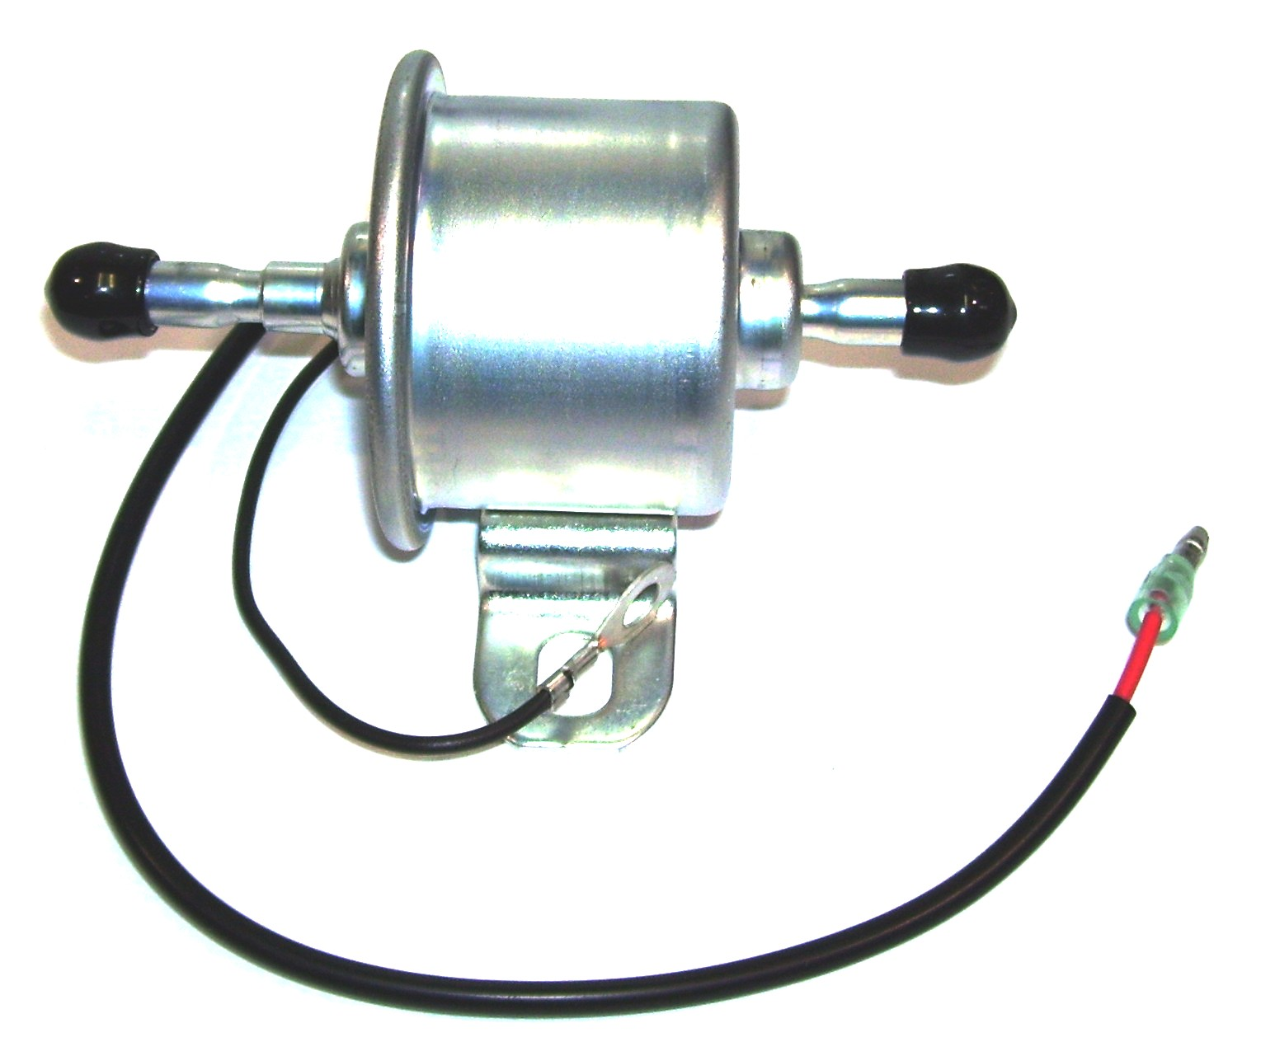

PP41-809003

Fuel Pump – Facet (Square)
Electric12vdc fuel pump, compatible with most small engines used on truck mounted carpet-cleaning machines. Replacement for Prochem 41-809003, Hydramaster 111-001 & White Magic J038

PP790549

Fuel Pump – Airtex
Prochem: Apex – Gas, Peak,
Everest & Everest HP (Non-EFI)
Can be used as a replacement on
other machines with recirculating
fuel system.

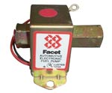
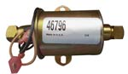

Fuel Pump EFI
Hydramaster: Titan 875
Blueline: Thermal Wave II & II HP
GMC Vortec EFI units only

PP790860

Fuel Pump EFI
Prochem: Everest & Everest HP
Blueline: Thermal Wave 5M & 5M HP
Nissan EFI units only

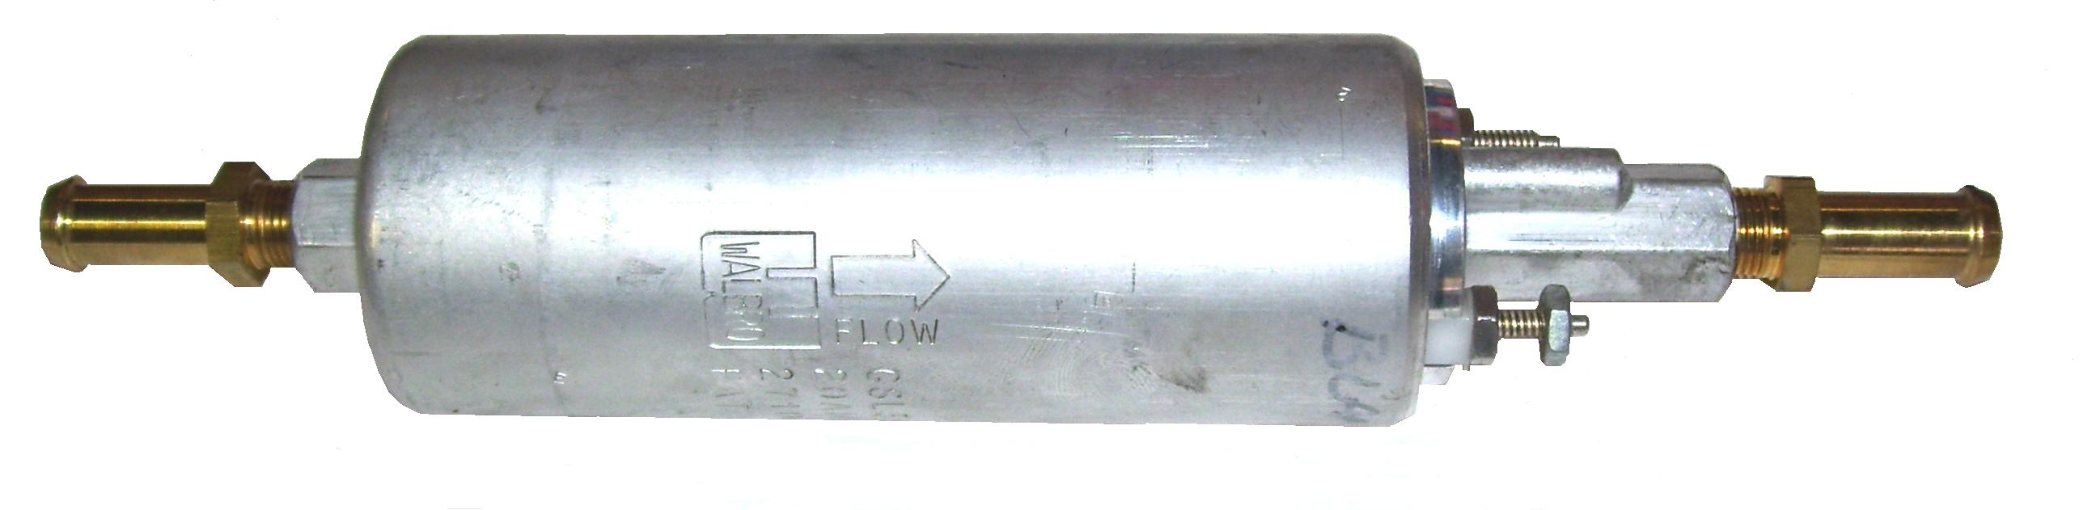

PP791355

Fuel Pump EFI
Prochem: Everest 408, Everest 408 HP, Everest 650 & Everest 650 HP
Hyundai EFI units only

PP790858

Fuel Filter EFI
Prochem: Everest & Everest HP
Blueline: Thermal Wave 5M & 5M HP
Nissan EFI units only

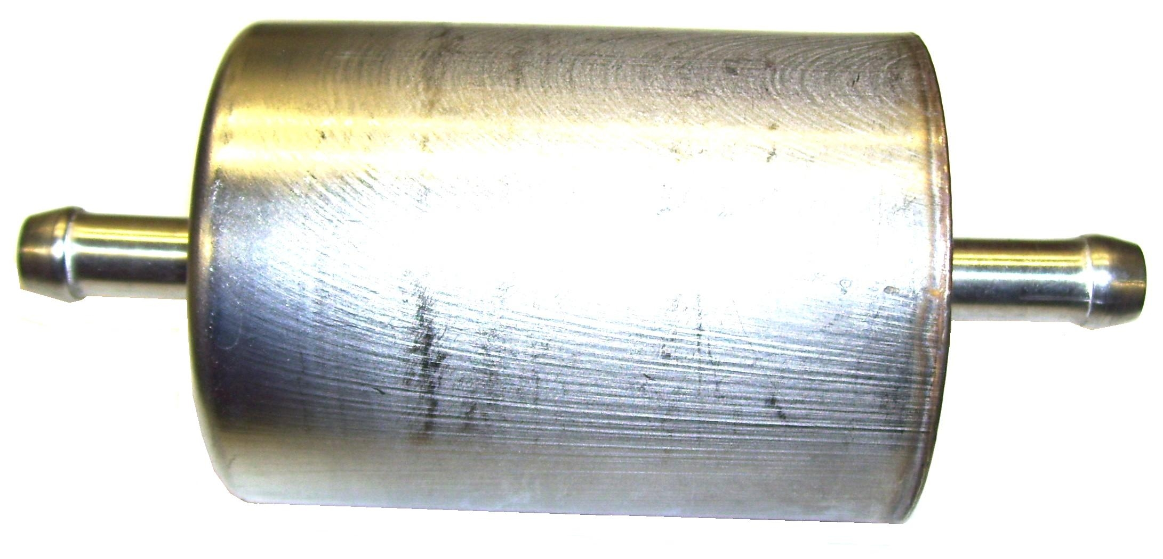

PBL36249

Fuel Filter EFI
Hydramaster: Titan 875
Blueline: Thermal Wave II & II HP
GMC Vortec EFI units only

PHY049-134
Filter Fuel Element – Diesel
Hydramaster: Maxx 450D Diesel

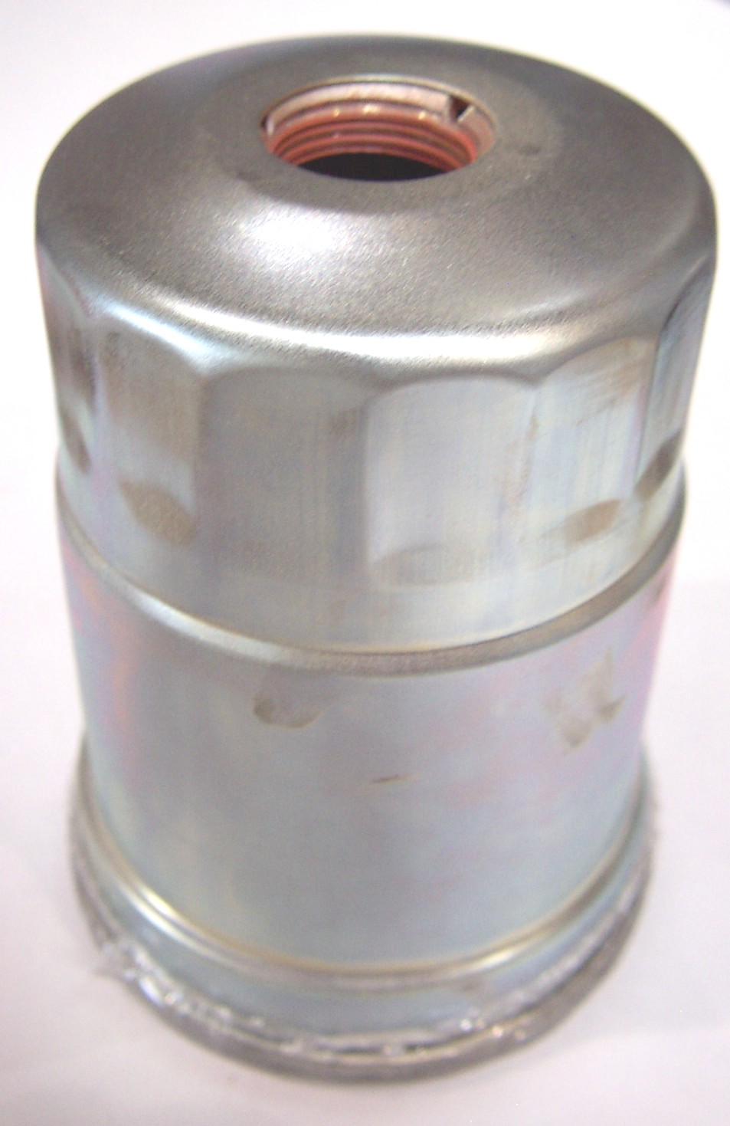

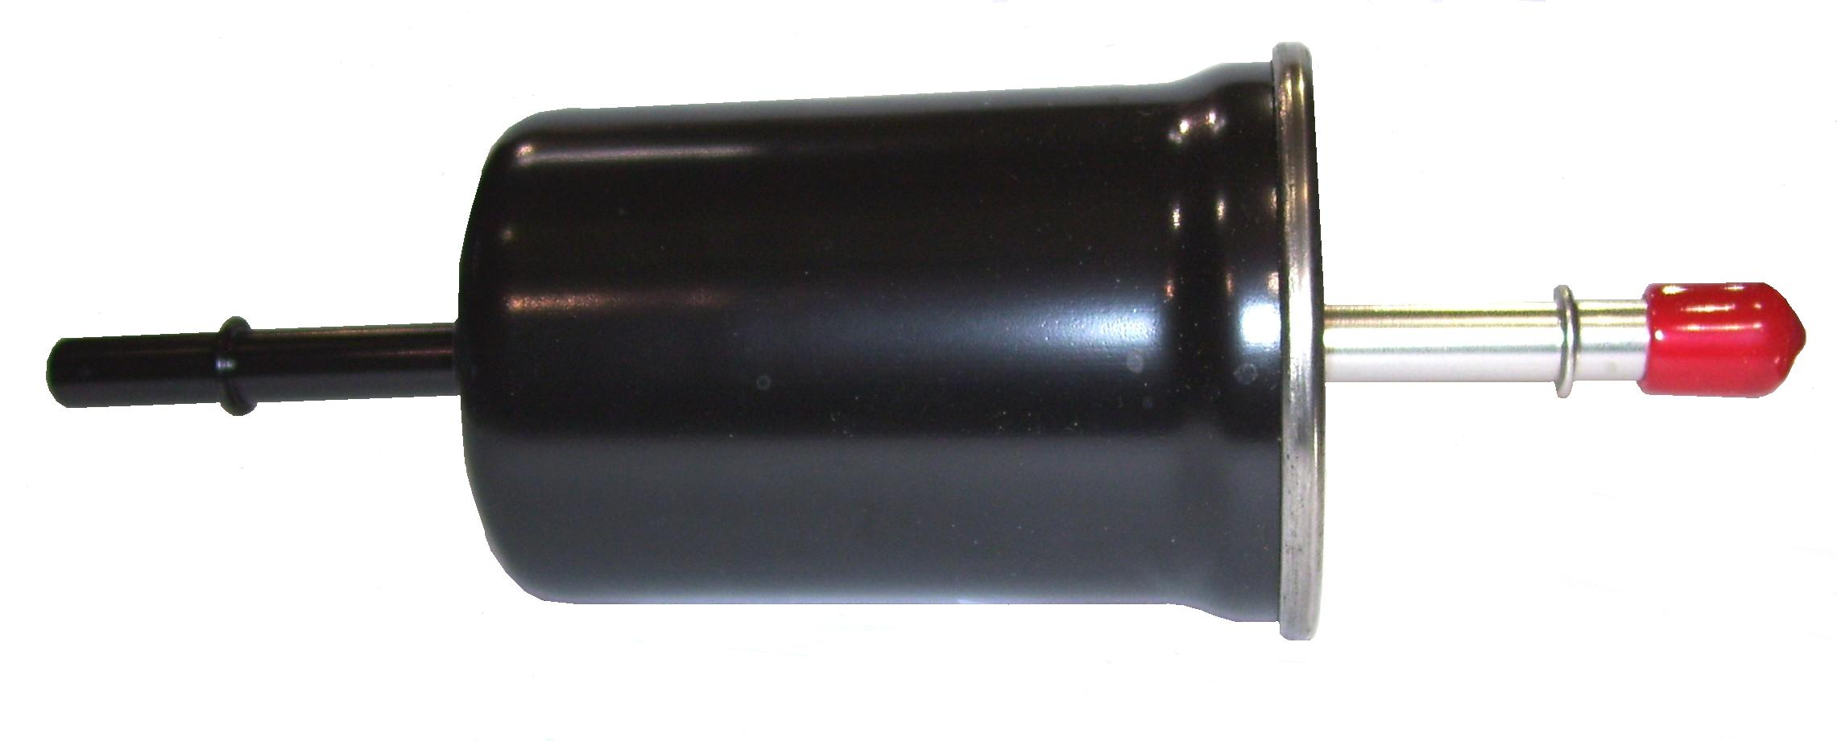

PNA3054
Fuel Filter – 5/16” Barbs
Metal fuel filter with by-pass barb for recirculating fuel systems.
(1/4” By-pass Barb) Replacement for Prochem 14-806574
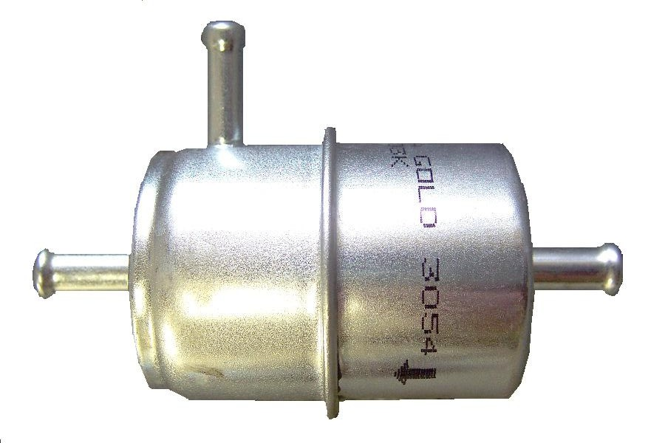

PP791356

Fuel Filter EFI
Prochem: Everest 408, Everest 408 HP, Everest 650 & Everest 650 HP
Hyundai EFI units only

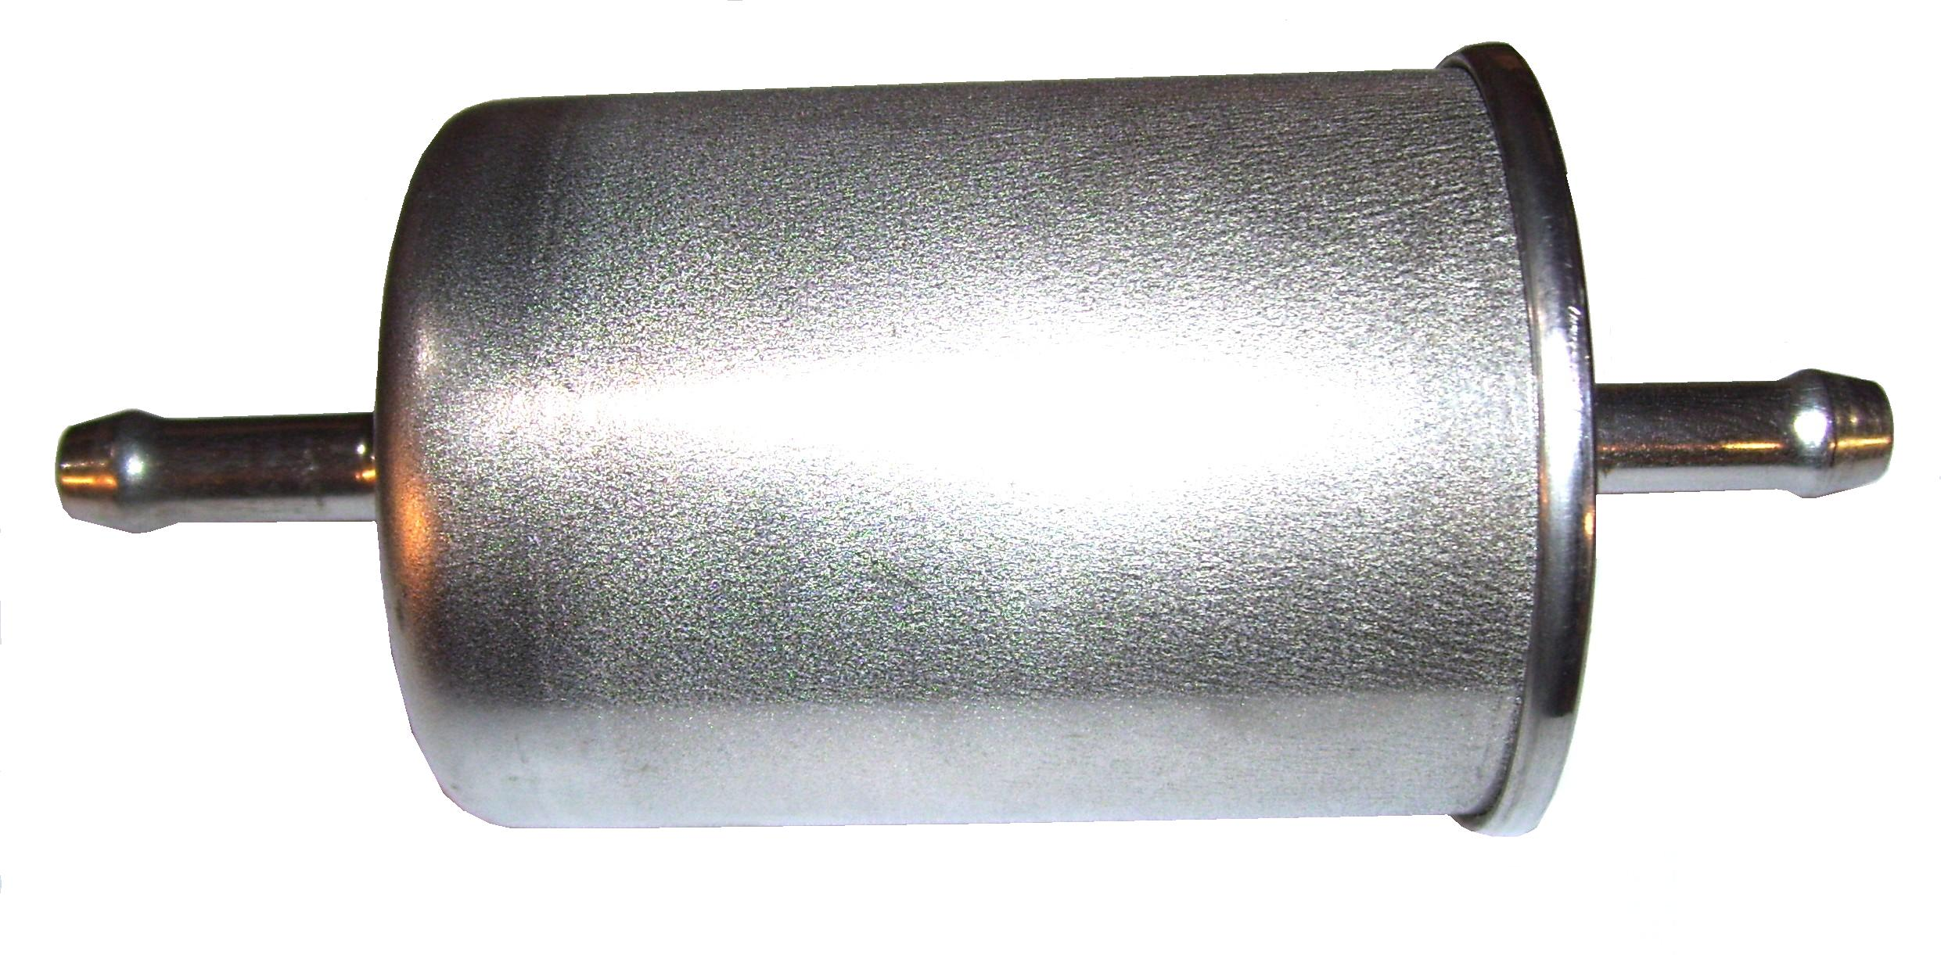

PP42-902311
Fuel Filter – 5/16” Barbs
Plastic fuel filter

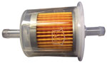

PHY049-002
Fuel Filter – 5/16” Barbs
Metal fuel filter

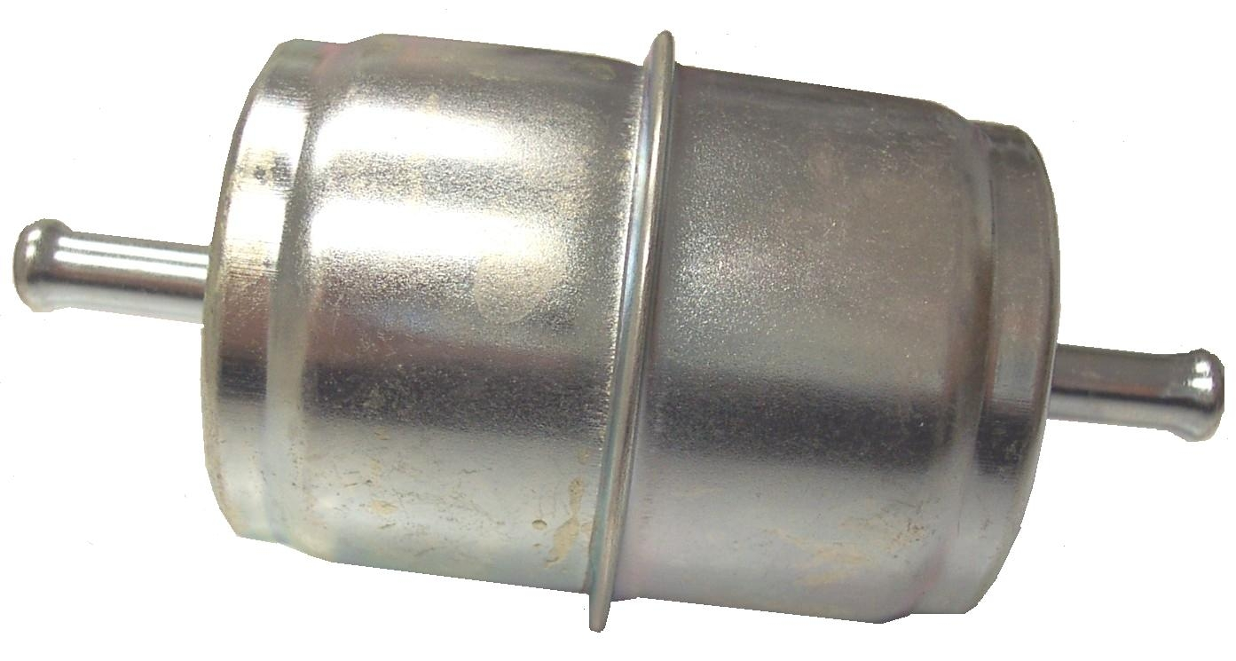

PBL36244

Fuel Line Adapter QD - GMC

5/16” Barb

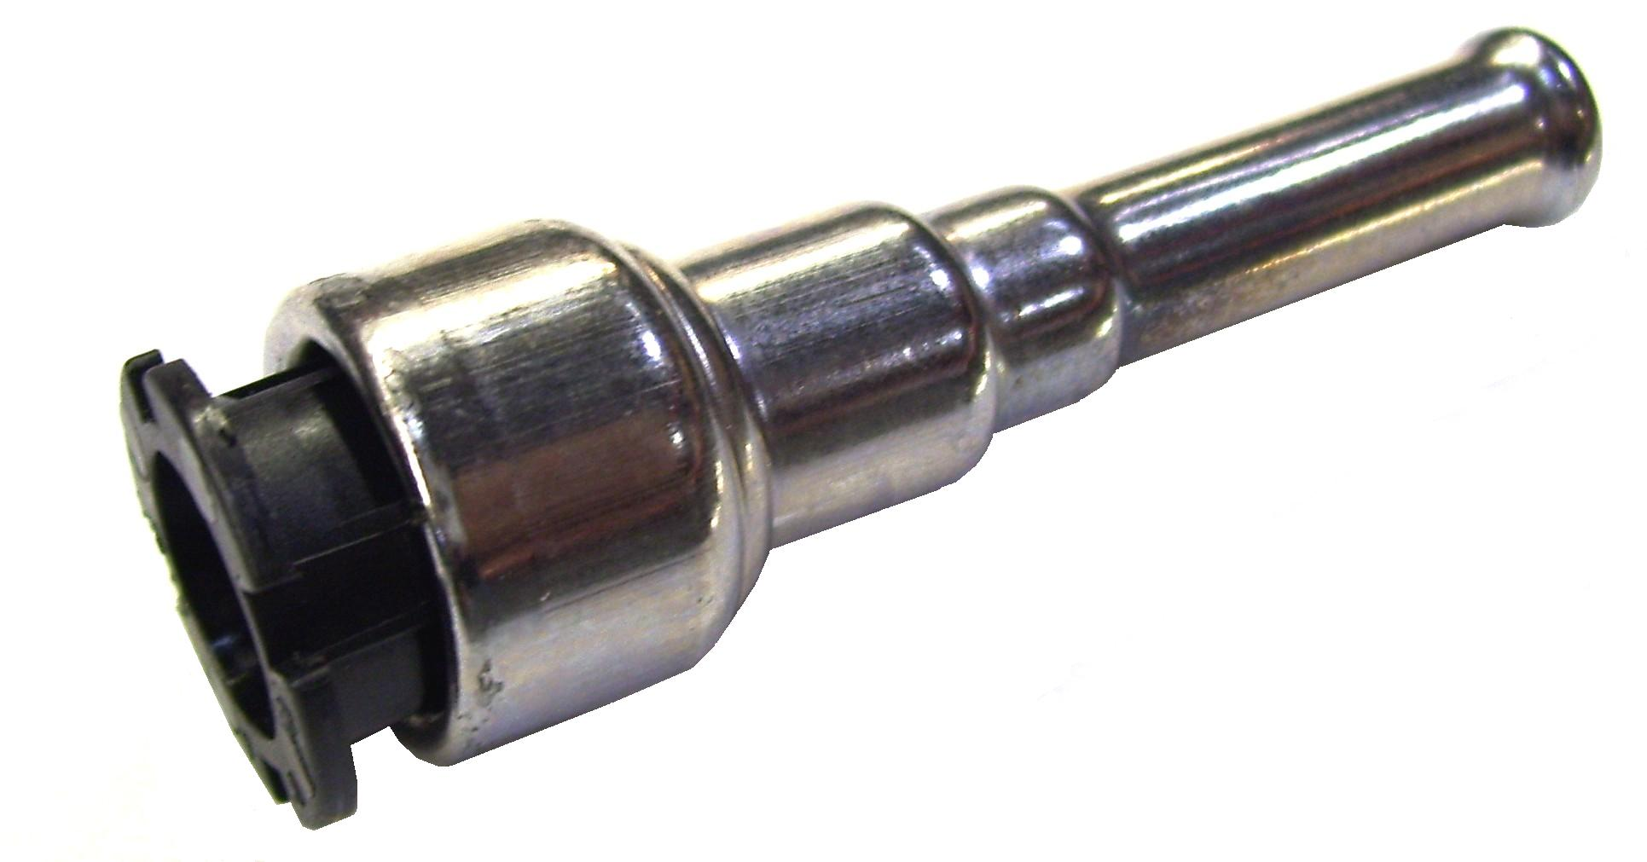

PHY049-049
Fuel Filter – 1/4” Barbs
Metal fuel filter

PBL66169

Fuel Line Adapter QD - GMC

Threaded End

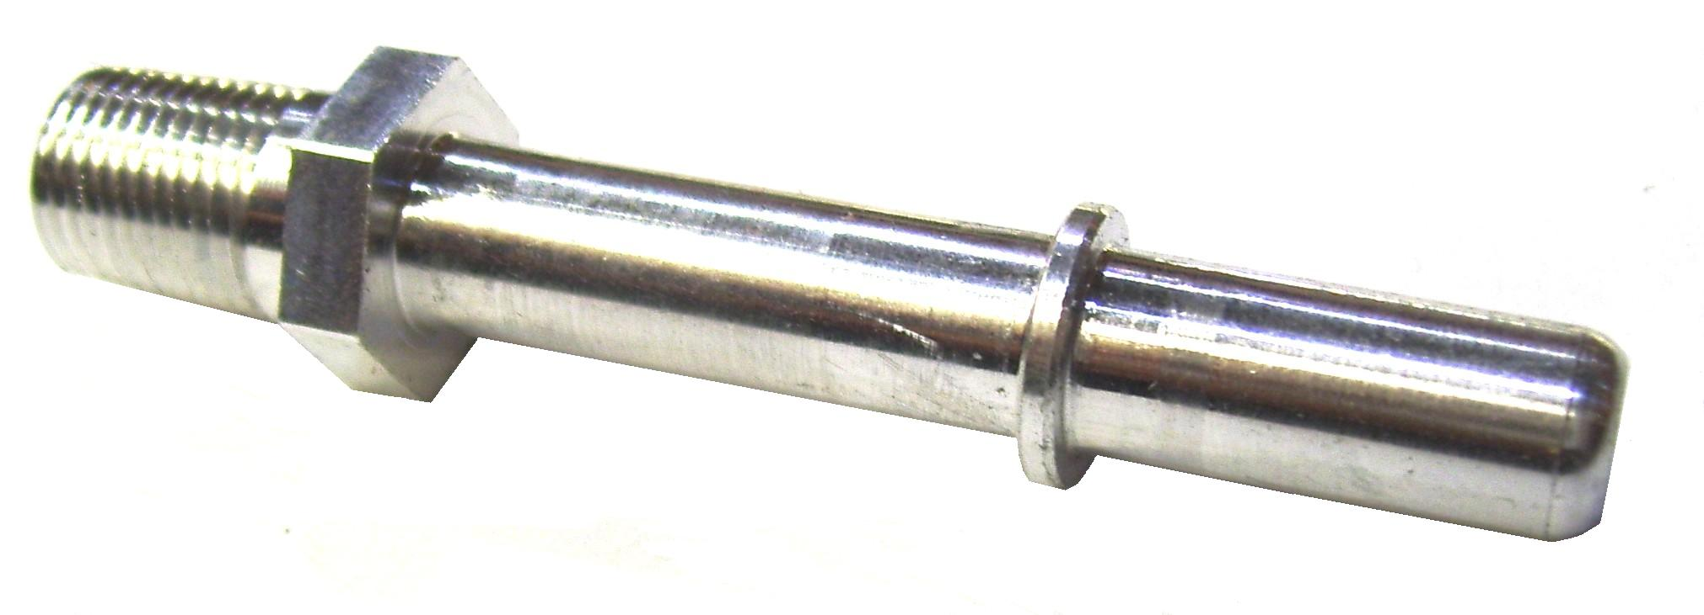

Bridgepoint Parts Catalog

Section IV: Truckmount Fuel Systems Page 2

PP66-945153

Fuel Line Install Kit – General
Used on pre-1997 Chevy vans, pre-1998 Dodge vans, pre-1992 Ford vans.

Includes fittings and hose to connect to machine.

PP66-945171

Fuel Line Install Kit – 1992-2003 Ford
Also used on 1998+ Dodge Vans
Fuel tap parts only. Does not include fittings and hose to connect with machine. If these parts are not included with the machine, you will need the General Fuel Line Install Kit PP66-945153.

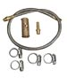
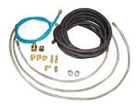

PP66-945437

Fuel Line Install Kit – 1997- 2002 Chevy
Also used on pre-1998 Dodge Vans.
Fuel tap parts only. Does not include fittings and hose to connect with machine. If these parts are not included with the machine, you will need the General Fuel Line Install Kit PP66-945153.

PHY078-110

Kit Line Install Kit 1999-2003 Ford

For Non-recirculating Systems
Fuel tap parts only. Does not include fittings and hose to connect with machine. If these parts are not included with the machine, you will need the General Fuel Line Install Kit PP66-945153.

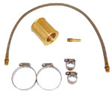

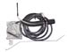

PHY078-407

Kit Line Install Kit 2003-2013 Chevy / GMC

Recirculating Systems
Fuel tap parts only - does not include fittings to connect with machine.

PHY078-425

Kit Fuel Line Install

2004 – 2010 Ford

Recirculating Systems
(Does not include fuel pump.)
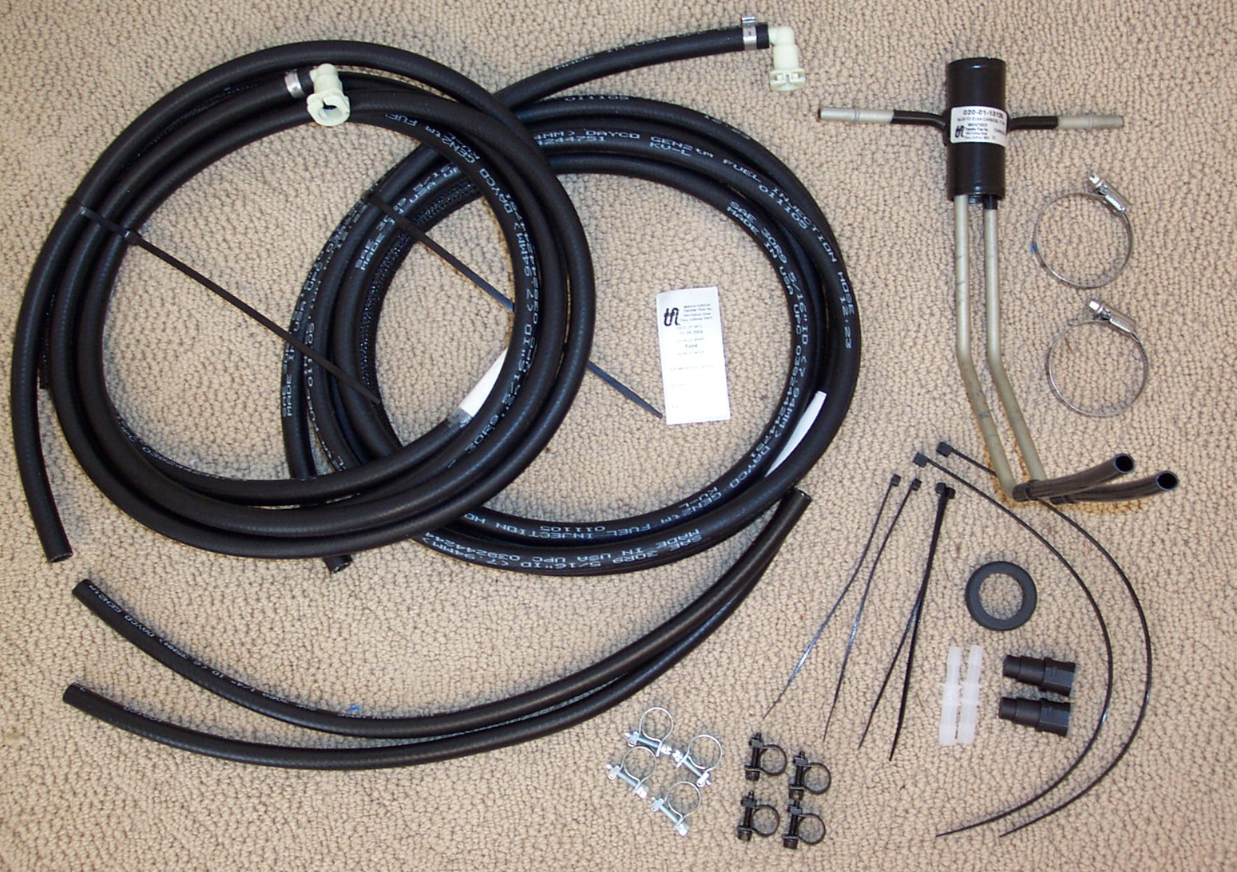

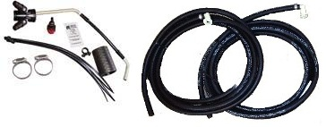

PTF115271

Kit Fuel Line Install

2011 – 2013 Ford

Recirculating Systems
(Does not include fuel pump.)

PP66-945576

Fuel Line Install Kit – 1997- 2002 Chevy Cargo Van
Fuel tap parts only. Does not include fittings and hose to connect with machine. If these parts are not included with the machine, you will need the General Fuel Line Install Kit PP66-945153.

DISCONTINUED

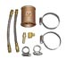

PTF115305

Kit Fuel Line Install

2011 – 2013 NISSAN

Recirculating Systems
(Does not include fuel pump.)

PP790847

Kit Fuel Hook-up Without Pump for EFI Units

2004 -2010 GM & FORD

With Auxiliary Fuel Ports
(Does not include fuel pump)

BR018

Barb 3/8” x 1/8”mpt

BR019

Barb 5/16” x 1/4”mpt
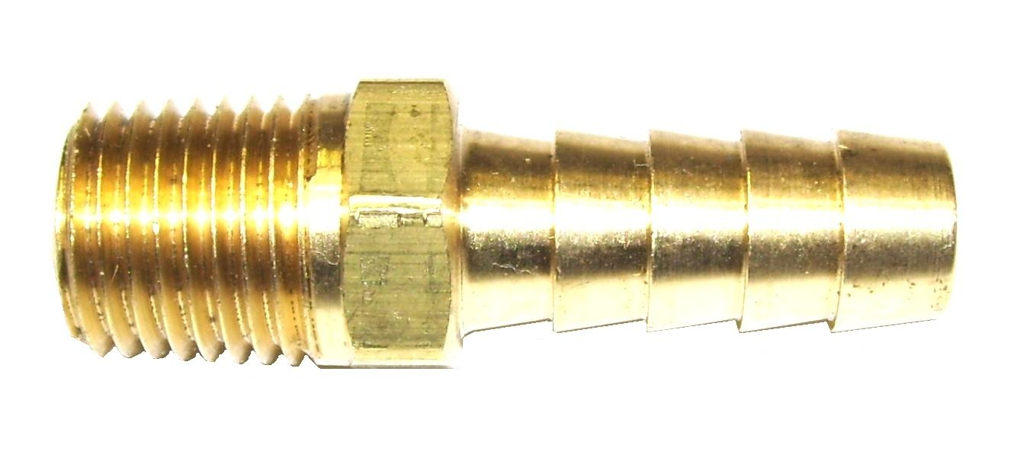

Bridgepoint Parts Catalog

Section IV: Truckmount Fuel Systems Page 3

PP790562

Kit Fuel Hook-up W/Pump

1992-2003 FORD 98+ DODGE

PP790744

Kit Fuel Hook-up W/Pump 2004 – 2009 FORD

With/ Auxiliary Fuel Port

DISCONTINUED

DISCONTINUED

PP790809

Kit Fuel Hook-up W/Pump 2004 – 2009 GM

With Auxiliary Fuel Port

PP790753

Kit Fuel Hook-up W/Pump 2004 – 2009 GM / FORD Without Auxiliary Fuel Port

DISCONTINUED

DISCONTINUED

BR259

Elbow 90° 1/4” flare x 1/8”mpt

PP790546

Adapter Fuel Fitting w/ Return

1992-2003 Ford / Dodge
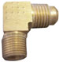

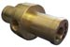

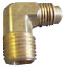

BR260

Elbow 90° 1/4” flare x 1/4”mpt

PP52-501625

Fuel Fitting – 1992-2003 Ford

Fitting Only

Also used on 1998+ Dodge Vans

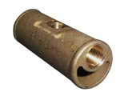

BR280

Elbow 90° 1/8” Street M-F

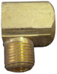

PP790703

Fitting – Fuel Return

2004 GM / FORD

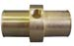

BR282

Elbow 90° 1/4” Street M-F

BR010

Barb 1/4” x 1/8”mpt

PP790533

Adapter Fuel Fitting

2003 GM

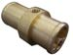

BR012

Barb 1/4” x 1/4”mpt
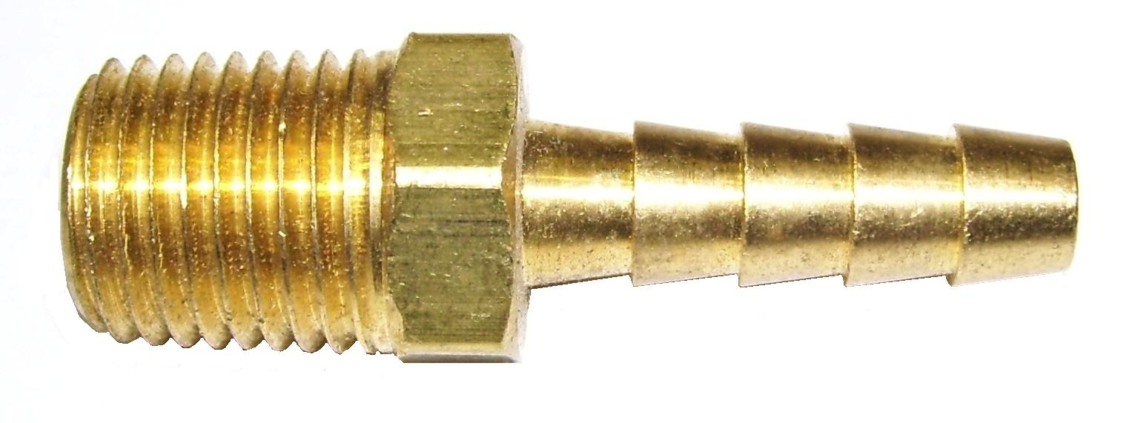

PP52-501774

Fuel Fitting – 1997- 2002 Chevy
Fitting Only

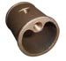

BR017

Barb 5/16” x 1/8”mpt

BR020

Barb 3/8” x 1/4”mpt

PFR394358

Fuel Filter – Briggs

75 micron

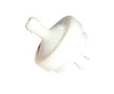

PFR493629

Fuel Filter – Briggs

60 micron

PP11-800091

Bulkhead Fitting 1/8”FPT

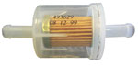
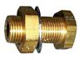

PGE149-2206
Fuel Filter

Plastic fuel filter
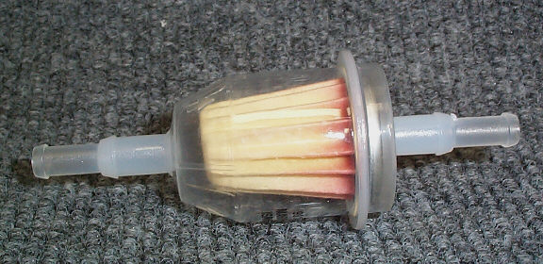

NM5087

Bulkhead Fitting 1/4”FPT

